**The fast greedy search. (Project for an algorithm that reduces the risk of sexual harassment)**

| Maximiliano Sanchez Lara  Universidad Eafit  Colombia  Msanchezl2@eafit.edu.co | Santiago Celis  Universidad Eafit  Colombia  scelisl@eafit.edu.co | Andrea Serna Universidad Eafit Colombia asernac1@eafit.edu.co | Mauricio Toro  Universidad Eafit  Colombia  mtorobe@eafit.edu.co |
| --- | --- | --- | --- |

Integrant extra(Con el permiso del profesor):Felipe Gomez Daza

Universidad Eafit

Colombia

fgomezd1@eafit.edu.co

# **ABSTRACT**

# In this project we want to take a look into sexual harrasment in the streets. Sexual harrasment isn’t only limited to fear dividing itself into other problems like work deficiency, suicides, and unwanted pregnancies. Creating an algorithm that creates the shortest routes to avoid and lower these risks is the objective in this project.

## **Key words**

| Shortest route, street sexual harassment, identification of safe routes, crime prevention |
| --- |

# **1. INTRODUCTION**

# Sexual harrasment is when people get harrased by the opposite sex and it can happen everywhere, some examples being public spaces like the streets and private spaces. Sexual harrasment in the streets could be easily prevented if they knew what routes are safe to take to get to their destination. This could be implemented by creating a new navigation algorithm that calculates the shortest and safest paths to reach a certain destination by taking into account already researched data on the paths with the most sexual harrasment and the distances between them.

# **1.1. The problem**

The current problem is to calculate three different routes that reduce distance and risk. In order to give the user a variety of routes depending on their current needs and lower the amount of victims to sexual harrasment. Solving this problem would be an advance to current navigation systems where getting you to your location is their only objective instead of considering your full safety.

**1.2 Solution**

We chose a dijkstra algorithm in order to find the shortest possible distances or risk values possible from one location to another. The reason we chose dijkstra was because the time complexity is one of the shortest possible ones. We also have the advantage of no negative weights in our graph allowing it to work perfectly and faster than other algorithms that take it into account.

**1.3 Structure of the article**

Next, in Section 2, we present work related to the problem. Then, in Section 3, we present the datasets and methods used in this research. In Section 4, we present the algorithm design. Then, in Section 5, we present the results. Finally, in Section 6, we discuss the results and propose some directions for future work.

**2. RELATED WORK**

Below, we explain four works related to finding ways to prevent street sexual harassment and crime in general.

# **2.1 Beyond the Shortest Route: A Survey on Quality-Aware Route Navigation for Pedestrians**

# The project consists of the route navigation systems today that don't consider other factors instead they only consider the shortest route. The shortest route isn't everything for a quality navigation system. There is so much more than just the shortest route like safety, scenery, and others. This project wishes to recognize routes and give them weights depending on what they are needed for on the variables. For this reason they considered using dijkstra's algorithm in order to examine all of these subdivided routes. Since there doesn’t exist a measuring unit that measures all variables universally and can be compared then they had to divide the responses into different categories which we will only be talking about the responses on visited locations. After which they obtained pretty good results when they weighted routes based on popular spots based on popular opinion based on social media but they did not seem to please the people in the minorities like disabled people who don't often appear in those types of sources[1].

## **2.2 Preventing Sexual Harrasment Through a Path Finding Algorithm Using Nearby Search**

The problem in this related work is to find a way to avoid sexual harrasment using a heatmap. The heatmap they create will contain the areas where sexual harrasment has presented itself making them use Bresenham’s algorithm to find the safest route between each spot that seems to be safe in the heatmap. After this they apply a scoring system from how safe the route is to how dangerous it can be and choose the safest route from all the previous generated ones. Since this is only a research work on a solution that can be applied it has not gone into testing whether it works or it doesn’t.[2]

2.3 **Route - The Safe: A Robust Model for Safest Route Prediction Using Crime and Accidental Data**

People who are new to the city, have no idea about the safe routes. While traveling, you should be aware and choose the safest route. Safety and security became the top most priority of people due to the rising number of crimes in cities. For this situation, they proposed a solution divided in three algorithms. The first algorithm is called “Data Preprocessing Mask Algorithm”, that consists of data collection, between them are the arrest data (crime data) and the accident data. Later, they used parts of code, as they are RM (is a command from Unix family of operating systems used to remove files and directories from the file system. Unix family is a portable operative system), Na.rm (is an expression that consists in a condition that is if it minds values in the variable, it should remove them), Accident score of a point (this consists in the count of pedestrians, cyclists and motorists injured and killed), among other things. [3]

The second algorithm is called “K-Mean” or “K-Means” that is an unsupervised classification (clustering) algorithm that groups objects into k groups based on their characteristics. The grouping is done by minimizing the sum of distances between each object and the centroid of its group or cluster. Quadratic distance is often used.[3]

The algorithm consists of three steps:

Initialization: once the number of groups, k, is chosen, k centroids are established in the data space, for example, choosing them randomly.[3]

Assignment of objects to centroids: each data object is assigned to its closest centroid.[3]

Centroid update: the position of the centroid of each group is updated, taking as the new centroid the position of the average of the objects belonging to said group.[3]

And finally, the third and last algorithm is K Nearest Neighbor, also known as KNN or k-NN, is a non-parametric, supervised learning classifier, which uses proximity to make classifications or predictions about the grouping of an individual data point.[3]

## **2.4 Safety-aware routing for motorized tourists based on open data and VGI**

The project consists in explain the situation of the actual political conflicts and global terrorism. These terms are around the world that appear as parallel societies inside countries with great economic power due to social segregation. These areas imply high degree of crimes connected with violence, drug abuse and prostitution. The perception of urban danger often goes together with globally supported stereotypes. To recover the security and avoid the criminal acts, they decided to use the “OPTICS”algorithm (Ordering points to identify the clustering structure).[5]

## **3. MATERIALS AND METHODS**

In this section, we explain how the data were collected and processed, and then different alternative path algorithms that reduce both the distance and the risk of sexual street harassment.

## **3.1 Data collection and processing**

The map of Medellín was obtained from *Open Street Maps* (OSM)[1]  and downloaded using the Python API[2] OSMnx. The map includes (1) the length of each segment, in meters; (2) the indication of whether the segment is one-way or not, and (3) the known binary representations of the geometries obtained from the metadata provided by OSM.

For this project, a linear combination (LC) was calculated that captures the maximum variance between (i) the fraction of households that feel insecure and (ii) the fraction of households with incomes below one minimum wage. These data were obtained from the 2017 Medellín quality of life survey. The CL was normalized, using the maximum and minimum, to obtain values between 0 and 1. The CL was obtained using principal components analysis. The risk of harassment is defined as one minus the normalized CL. Figure 1 presents the calculated risk of bullying. The map is available on GitHub[3] .

**Figure 1.** Risk of sexual harassment calculated as a linear combination of the fraction of households that feel unsafe and the fraction of households with income below one minimum wage, obtained from the 2017 Medellín Quality of Life Survey.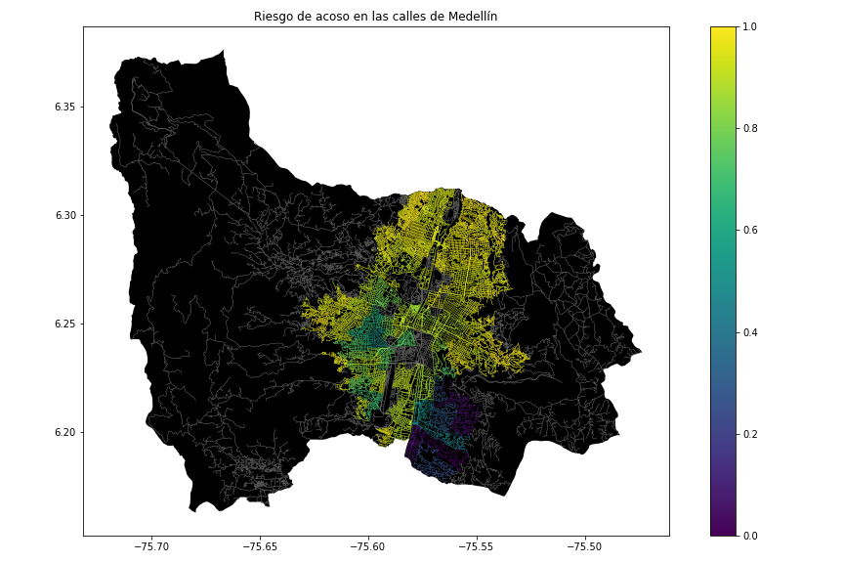

## **3.2 Algorithmic alternatives that reduce the risk of sexual street harassment and distance**

## In the following, we present different algorithms used for a path that reduces both street sexual harassment and distance.

**3.2.1 Dijkstra**

Dijkstra’s algorithm consists in finding all distances from an origin point to different points or nodes you could call them. It consists in turning all of the distances into a NxN matrix where N is gonna be the number of nodes that we are going to have, the matrix consists of placing the distance from an origin point to all the others. After we have all that we are going to grab an origin point in the NxN matrix and then find the minimum value in the origin Nx1 line we have. After that we compare the sum of that minimum value with the sum of a number in the matrix in the minimum position in a k position. If this is less than the number in our origin line in the k position then the number in the origin in that k position gets replaced by the sum of the number in the origin line in the minimum position and the number in the matrix in the minimum position in the k position.The restrictions are that you can't compare the same minimum position more than ounce and k cant take its value anymore after you use it. If we also don't know the distance from one point to another point then we just place the distance as infinite since the route doesn’t exist and will be replaced later. The weights can be applied to risk values or distance values and then compared in order to reach our location.

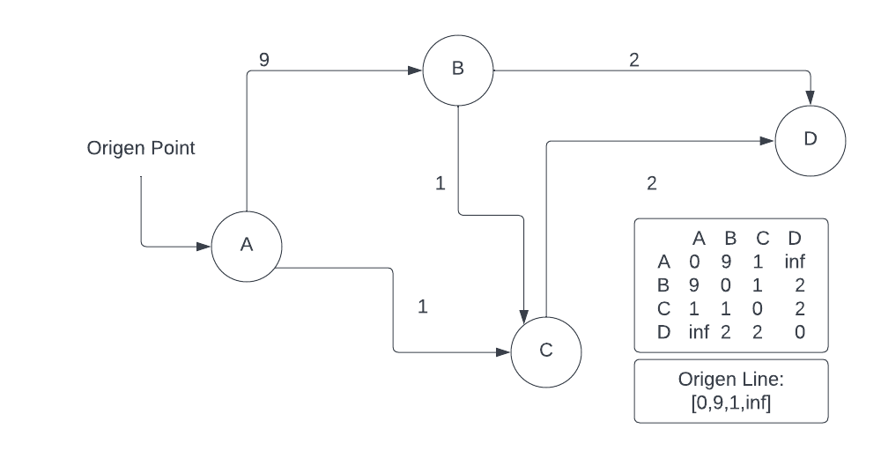

**3.2.2 Find the shortest path in a maze**

The shortest path in a maze algorithm consists in checking all selected paths through a backtracking technique until we find that minimum amount of distance again. The backtracking technique consists of creating an array with the same dimensions as the one in our maze or beginning array as you would call it. If we have already visited that place we would avoid and take another route by which if we reach nothing at the end of one of the routes we take we are going to set the end point as not visited and we are going to return the value minimum distance. In order to travel every single possible path we are going to create multiple parallel universes where each universe would have gone up, down, left, or right in order to reach the same destination through a different but shorter path. After this we only need our starting point to our ending point. The same idea applies to a map with color like a maze where all colors different to black are a route to follow towards a destination and it can also be applied towards risk factors where every color different than black is a risk towards our location.

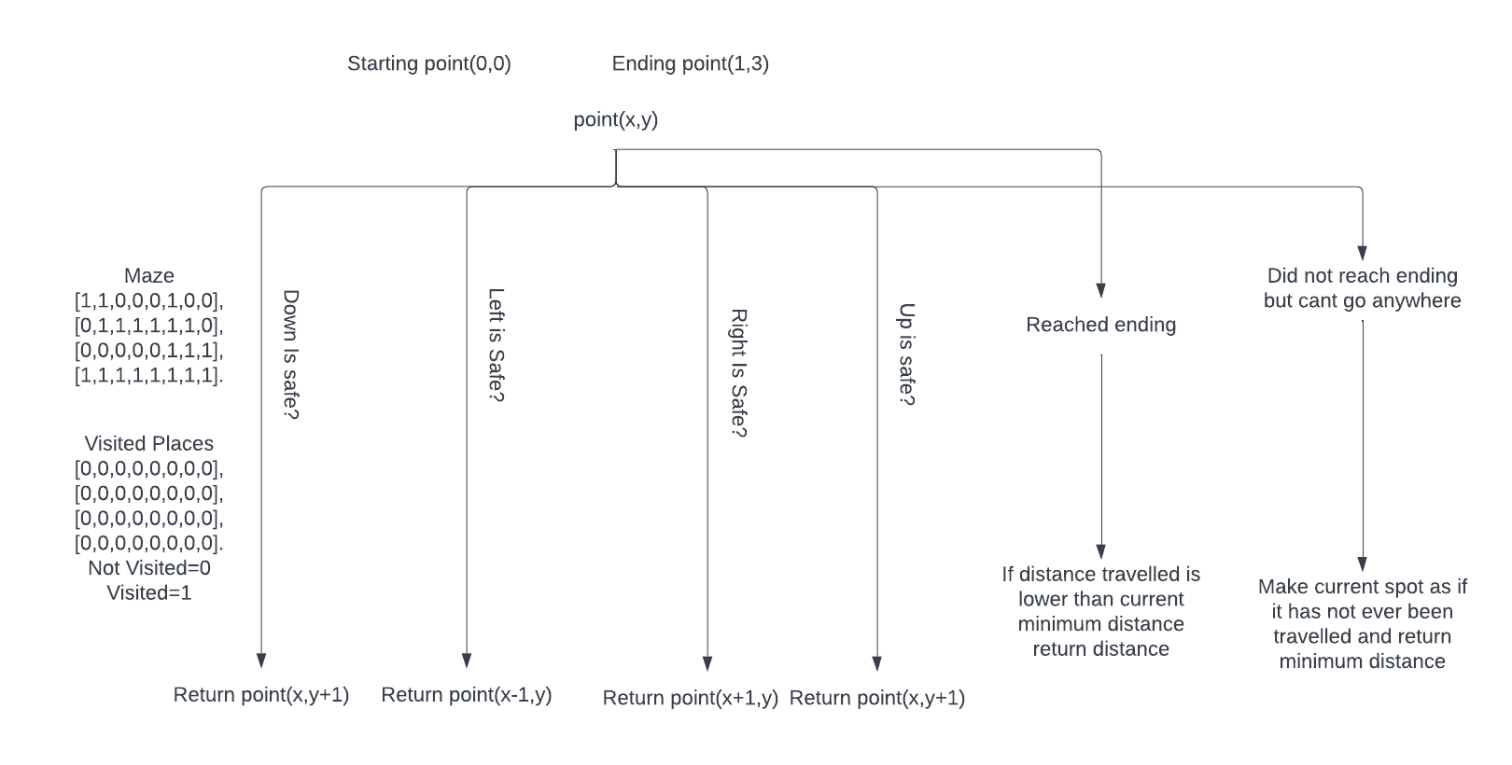

**3.2.3 Bresenham's line algorithm**

Bresenham's line algorithm is a line drawing algorithm that determines the we take in a dimensional plane with a point and a final point. For this algorithm we have to create a line from a starting point in the plane to a finishing point in the plane from the left to the right. The point S is the initial grid point and has already been determined to be traversed through. We then need to determine the current grid point to be shaded with regard to the previous point. To do so, we also consider the grid points M and LN (for East and Northeast of the current grid point respectively). MLN is the middle point between the M and LN (Northeast and East).[2]

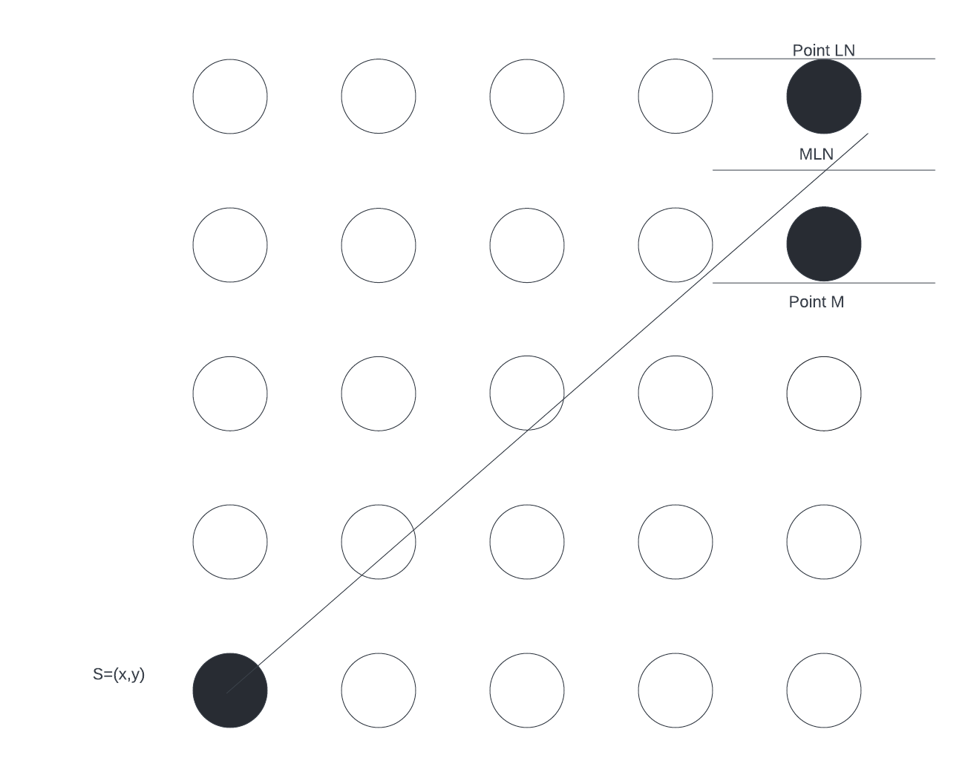

**3.2.4 OPTICS**

“OPTICS”(Ordering points to identify the clustering structure) algorithm is an algorithm for finding density-based clusters in spatial data). This is defined with a graphic representation with points and distance, where exists distances such as:

Core Distance: It is the minimum value of radius required to classify a given point as a core point. If the given point is not a Core point, then it’s Core Distance is undefined.

Reachability Distance: It is defined with respect to another data point q(Let). The Reachability distance between a point p and q is the maximum of the Core Distance of p and the Euclidean Distance(or some other distance metric) between p and q. Note that The Reachability Distance is not defined if q is not a Core point.

The minimum points are the minimum amount of points that could fit on the space.

[4]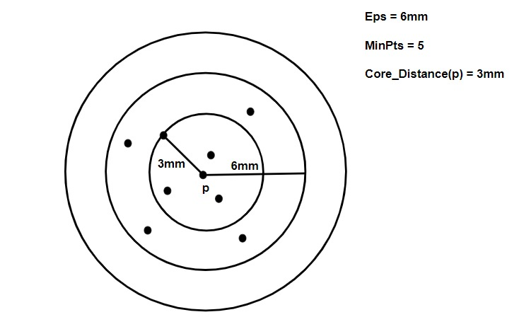

Image inspired by GeeksForGeeks[4]

## **4. ALGORITHM DESIGN AND IMPLEMENTATION**

## In the following, we explain the data structures and algorithms used in this work. The implementations of the data structures and algorithms are available on Github[4] .

## **4.1 Data Structures**

## Explain the data structure that was used to represent the map of the city of Medellín. Make a figure that explains it. Do not use figures from the Internet. *(In this semester, examples of data structures are adjacency matrix, adjacency list, adjacency list using a dictionary).* The data structure is presented in Figure 2.

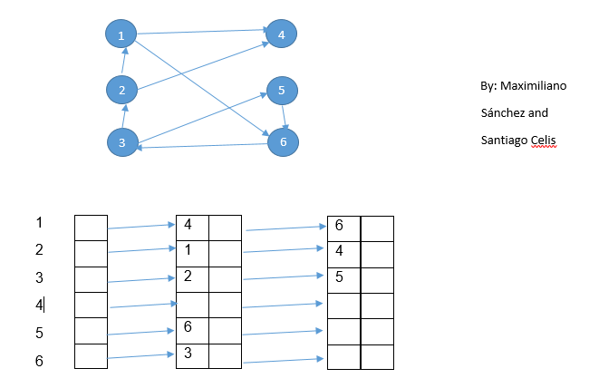

**Figure 2:** An example street map is presented in (a) and its representation as an adjacency list in (b). (*Please feel free to change this graph if you use a different data structure*).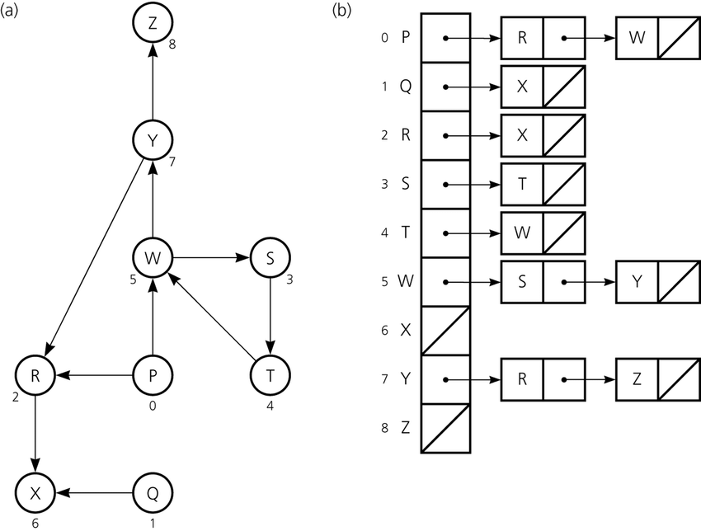

**4.2 Algorithms**

In this paper, we propose an algorithm for a path that minimizes both the distance and the risk of street sexual harassment.

**4.2.1 Algorithm for a pedestrian path that reduces both distance and risk of sexual street harassment**

Explain the design of the algorithm for calculating a path that reduces both distance and risk of harassment and make your own graph. Do not use graphs from the Internet, make your own. *(In this semester, the algorithm could be DFS, BFS, Dijkstra, A*, Bellman, Floyd among others ).* The algorithm is exemplified in Figure 3.

**Figure 3:** Calculation of a path that reduces both distance and risk of harassment (please feel free to change this figure if you use a different algorithm).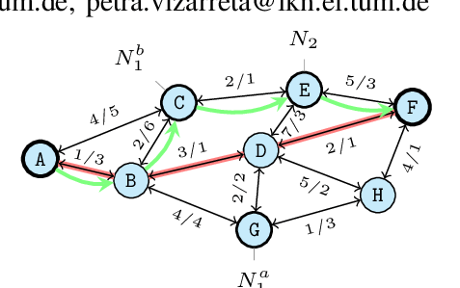

**4.2.2 Calculation of two other paths to reduce both the distance and the risk of sexual street harassment**

Explain the other two paths that reduce both distance and risk of street sexual harassment and make your own graph. Do not use graphs from the Internet, make your own. *(In this semester, the algorithm could be DFS, BFS, Dijkstra, A*, among others).* ) The algorithm is exemplified in Figure 4.

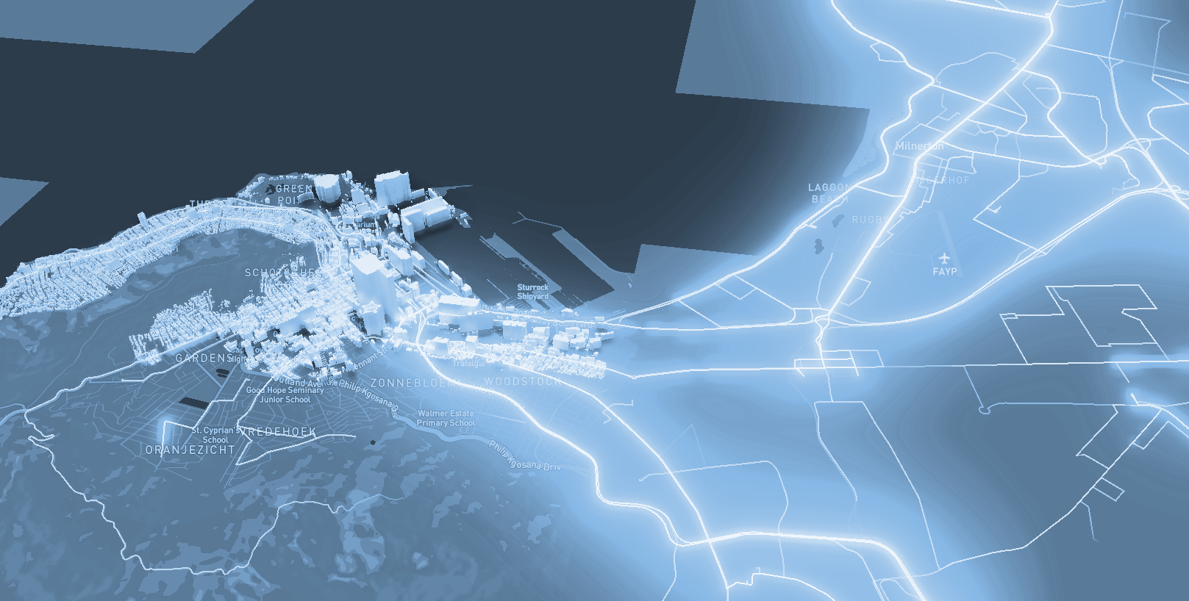

**Figure 4:** Map of the city of Medellín showing three pedestrian paths that reduce both the risk of sexual harassment and the distance in meters between the EAFIT University and the National University.

**4.3 Algorithm complexity analysis**

Explain, in your own words, the analysis, for the worst case, using the notation O. How did you calculate these complexities? Explain briefly.

| **Algorithm** | **Time complexity** |
| --- | --- |
| Algorithm name | O(V2 *E2 ) |
| Name of the second algorithm (in case you have tried two) | O(E3 *V*2V ) |

**Table 1:** Time complexity of the name of your algorithm, where V is.... E is... *(Please explain what V and E mean in this problem). No, do not use 'n'.*

| **Data Structure** | **Complexity of memory** |
| --- | --- |
| Name of the data structure | O(V*E*2E  ) |
| Name of the second data structure (in case you have tried two) | O(2E* 2V ) |

**Table 2:** Memory complexity of the data structure name used by your algorithm, where V is.... E is... *(Please explain what V and E mean in this problem). No, don't use 'n'. That is, don't use 'n'. Not 'n'.*

**4.4 Algorithm design criteria**

Explain why the algorithm was designed that way. Use objective criteria. Objective criteria are based on efficiency, which is measured in terms of time and memory. Examples of NON-objective criteria are: "I was sick", "it was the first data structure I found on the Internet", "I did it the last day before the deadline", "it's easier", etc. Remember: This is 40% of the project grade.

The Dijkstra algorithm

**5. RESULTS**

In this section, we present some quantitative results on the three pathways that reduce both the distance and the risk of sexual street harassment.

**5.1 Results of the paths that reduces both distance and risk of sexual street harassment**

Next, we present the results obtained from *three paths that reduce both distance and harassment,* in Table 3.

| **Origin** | **Destination** | **Distance** | **Risk** |
| --- | --- | --- | --- |
| Eafit | Unal | ?? | ?? |
| Eafit | Unal | ??? | ?? |
| Eafit | Unal | ?? | ?? |

Distance in meters and risk of sexual street harassment (between 0 and 1) to walk from EAFIT University to the National University.

**5.2 Algorithm execution times**

In Table 4, we explain the ratio of the average execution times of the queries presented in Table 3.

Calculate the execution time for the queries presented in Table 3.

## 

| **Calculation of v** | **Average run times (s)** |
| --- | --- |
| v = ?? | 100000.2 s |
| v = ?? | 800000.1 s |
| v = ?? | 8450000 s |

## **Table 4:** *Algorithm* name execution times *(Please write the name of the algorithm, e.g. DFS, BFS, A*)* for each of the three calculator paths between EAFIT and Universidad Nacional.

## **6. CONCLUSIONS**

Explain the results obtained. Are the paths significantly different? How useful is this for the city? Are the runtimes reasonable to use this implementation in a real situation? Which path would you recommend for a mobile or web application?

**6.1 Future work**

Answer, what would you like to improve in the future? How would you like to improve your algorithm and its application? Will you continue this project working on optimization? Statistics? Web development? Machine learning? Virtual reality? How?

# **ACKNOWLEDGEMENTS**

Identify the type of thank you you wish to write: to a person or to an institution. Keep the following guidelines in mind: 1. The professor's name is not mentioned because he or she is an author. 2. You should not mention the authors of articles that you have not contacted. 3. You should mention students, teachers of other courses who have helped you.

By way of example: This research has been supported/partially supported by [Name of Foundation, Donor].

We are grateful for help with [particular technique, methodology] to [First name Last name, position, name of institution] for comments that greatly improved this manuscript.

The authors thank Professor Juan Carlos Duque, Universidad EAFIT, for providing the data from the 2017 Medellín Quality of Life Survey, processed in a *Shapefile*.

# **REFERENCES**

1. Siriaraya, P., Zhang, Y., Wang, Y., Wakamiya, S., Jeszenszky, P., Kawai, Y. and Jatowt, A. Beyond the Shortest Route: A Survey on Quality-Aware Route Navigation for Pedestrians, 2020.Retrieved August 14,2022, from ResearchGate: <https://www.researchgate.net/publication/343251733_>

2. Ma, D., 2020. Preventing Sexual Harassment Through a Path Finding Algorithm Using Nearby Search, 2020. Retrieved August 15,2022, from Omdena: <https://omdena.com/blog/path-finding-algorithm>

3.Soni, S., Sandeep, C. and Gauri Shankar, V.Route-The Safe: A Robust Model for Safest Route Prediction Using Crime and Accidental Data, 2019. Retrieved August, 15,2022, from ResearchGate: <https://www.researchgate.net/publication/338096313_Route-The_Safe_A_Robust_Model_for_Safest_Route_Prediction_Using_Crime_and_Accidental_Data>

4. GeeksforGeeks. ML | OPTICS Clustering Explanation - GeeksforGeeks, 2019. Retrieved August 15,2022, from GeeksforGeeks : <https://www.geeksforgeeks.org/ml-optics-clustering-explanation>

5.Keler, A. and Damascene Mazimpaka, J. Safety-aware routing for motorised tourists based on open data and VGI, 2016. Retrieved August 15,2022, from ResearchGate: <https://www.researchgate.net/publication/301566519_Safety-aware_routing_for_motorised_tourists_based_on_open_data_and_VGI>

1. <https://www.openstreetmap.org/>
2. https://osmnx.readthedocs.io/
3. https://github.com/mauriciotoro/ST0245Eafit/tree/master/proyecto/Datasets
4. http://www.github.com/ ????????? /.../project/